

Software Engineering Department

Capstone Project Phase A

**Dopamine Booster Game**

(24-2-D-12)

Dr. Natali Levi

Roee Barzilai – Roee159@gmail.com

Yuval Hilai - Yuvalos222@gmail.com

September 2024

**Contents**

1 Introduction 3

2 Background and Related Works 4

2.1 Medical Field: ADHD Treatment 4

2.2 Gamification 7

2.3 Current Solutions and Limitations 8

3 Expected Achievements 9

3.1 Outcomes 9

3.2 Success Criteria 10

4 Research and Engineering Process 13

4.1 Process 13

4.1.1 Research - Enhancing ADHD Treatment 13

4.1.2 Research – Cross Platform Mobile Development 14

4.2 Product 15

4.2.1 Requirements 15

4.2.2 Diagrams and Interfaces 16

5 Software Design and Architecture 19

6 Verification and Evaluation 21

6.1 Evaluation 21

6.1.1 Overview 21

6.1.2 Work Plan 22

6.1.3 Final Evaluation Stage 23

6.1.4 Reporting 23

6.2 Verification 24

7 References 25

8 AI-Tools 26

9 Appendix 27

**Abstract**

Attention-deficit/hyperactivity disorder (ADHD) is a neurodevelopmental disorder that affects millions of people worldwide and of all ages, characterized by persistent patterns of inattention, hyperactivity and impulsivity. These symptoms often lead to serious problems in everyday life, such as: difficulties with social interactions, work productivity, and academic performance. Current traditional treatments, including pharmacological and behavioral therapies, present challenges such as side effects, high cost, limited accessibility and often failing to maintain long-term symptom management. A major factor contributing to these challenges is the dysregulation and deficiency of dopamine, a neurotransmitter critical for maintaining concentration, motivation, and impulse control in the brain. To address these issues, we propose developing an innovative mobile application, the “Dopamine Booster Game”, designed to manage ADHD symptoms in a more accessible and engaging way. Our project leverages neuroscientific research and innovative game mechanics to stimulate dopamine production. The interactive platform provides activities to improve attention and cognitive function, providing a scalable and cost-effective intervention suitable for diverse populations. The "Dopamine Booster Game" is designed to be user-friendly and accessible and focuses on providing a fun, motivational, and effective tool for managing ADHD symptoms. The application is evaluated through iterative user testing and feedback to ensure its effectiveness and suitability for many users. By combining medical principles with innovative technological advances, the project aims to lay the foundation for revolutionizing the globally accepted treatment of ADHD.

**Keywords** **–** Attention-deficit, Hyperactivity disorder, ADHD treatment, Dopamine boost, Personal medicine, Education, Improving concentration, Research and Development, Mobile Game Therapy.

# **1 Introduction**

Attention-Deficit/Hyperactivity Disorder (ADHD) is a prevalent neurodevelopmental disorder that significantly impairs daily functioning and performance in various settings, including academic, occupational, and social environments [3]. Characterized by persistent patterns of inattention, impulsivity, and hyperactivity, ADHD affects both children and adults, leading to challenges in organizing tasks, following instructions and maintaining focus [2]. These difficulties often result in academic underachievement, workplace issues, and strained relationships.

One major underlying factor contributing to ADHD symptoms is the dysregulation of dopamine, a neurotransmitter crucial for motivation, reward, and pleasure [12]. Dopamine plays a vital role in attention, focus, and impulse control. In individuals with ADHD, dopamine pathways are often less active, making it challenging to experience motivation and reward, which contributes to difficulties in maintaining attention and controlling impulses.

Our research on ADHD indicates that the global standards for diagnosis and treatment are tailored to each patient and involve several key steps[1]. First, clinicians must recognize ADHD as a chronic condition and develop a treatment plan that includes educating the child and family about long-term management, involving school staff in collaboration and establishing specific target outcomes. Second, the clinician should assess the effectiveness of different treatment plans, recommending stimulant medications and/or behavioral therapy as appropriate to improve patient outcomes. Finally, regular follow-up is essential, focusing on outcomes and potential side effects, with input gathered from parents, teachers, and the child. In this standard treatment, medications aim to increase dopamine levels in the brain, improving attention and reducing hyperactivity and impulsivity. Behavioral therapies focus on developing organizational skills, time management, and strategies to improve focus. However, these treatments may not be suitable for everyone due to potential side effects, accessibility issues, and personal preferences.

To address the limitations of current treatments and provide an alternative or supplementary method for managing ADHD symptoms, we propose the development of a mobile application titled "Dopamine Booster Game". This project aims to create an interactive game designed to help children with ADHD by leveraging neuroscientific research and innovative game design principles. The primary objective is to stimulate the brain's production of dopamine through engaging and rewarding activities in the game, thereby improving attention and concentration in children with ADHD.

This project falls under both research and development categories, with its significance in its innovative approach to ADHD treatment. The development focuses on creating a functional prototype of the "Dopamine Booster Game," a game-based platform designed to provide an engaging and motivating experience for users. This game aims to improve attention and focus on a fun, interactive way and will be tested and refined based on user feedback and scientific data. At the end of each game session, exercises related to the learned material will appear, allowing us to measure the effectiveness of the game. This approach not only addresses ADHD symptoms but also helps individuals develop transferable skills such as task management, goal setting, and self-regulation.

# **2** **Background and Related Works**

## **2.1 Medical Field: ADHD Treatment**

Attention Deficit Hyperactivity Disorder (ADHD) is one of the most common childhood disorders, affecting approximately 3% to 6% of children globally [1]. It is characterized by symptoms of inattention, hyperactivity, and impulsivity that are inappropriate for a child's developmental level [1]. These symptoms can significantly impact various aspects of a child's life, including their academic performance, family dynamics, and social interactions [1][2]. ADHD treatment has traditionally relied

primarily on a combination of medication and behavioral therapy tailored to each individual and involves numerous necessary follow-ups [1].

Medications, including stimulants like methylphenidate and amphetamines, as well as non-stimulants like atomoxetine, are commonly used [4]. These medications work by affecting neurotransmitter levels in the brain, particularly dopamine, which is crucial for attention and impulse control [3]. However, medications often have side effects such as sleep disturbances, appetite suppression, and mood swings [4], leading to a need for non-pharmacological interventions.

Behavioral therapies, such as Cognitive Behavioral Therapy (CBT), focus on modifying negative thought patterns and behaviors [5]. Parent training programs and social skills training are also effective in managing ADHD symptoms [6]. Despite their effectiveness, these therapies require regular sessions with trained professionals, making them costly and time-consuming.

The traditional treatment algorithm for ADHD involves a step-by-step approach that integrates medication and behavioral therapy. The following figure illustrates this algorithm, based on clinical guidelines [1].

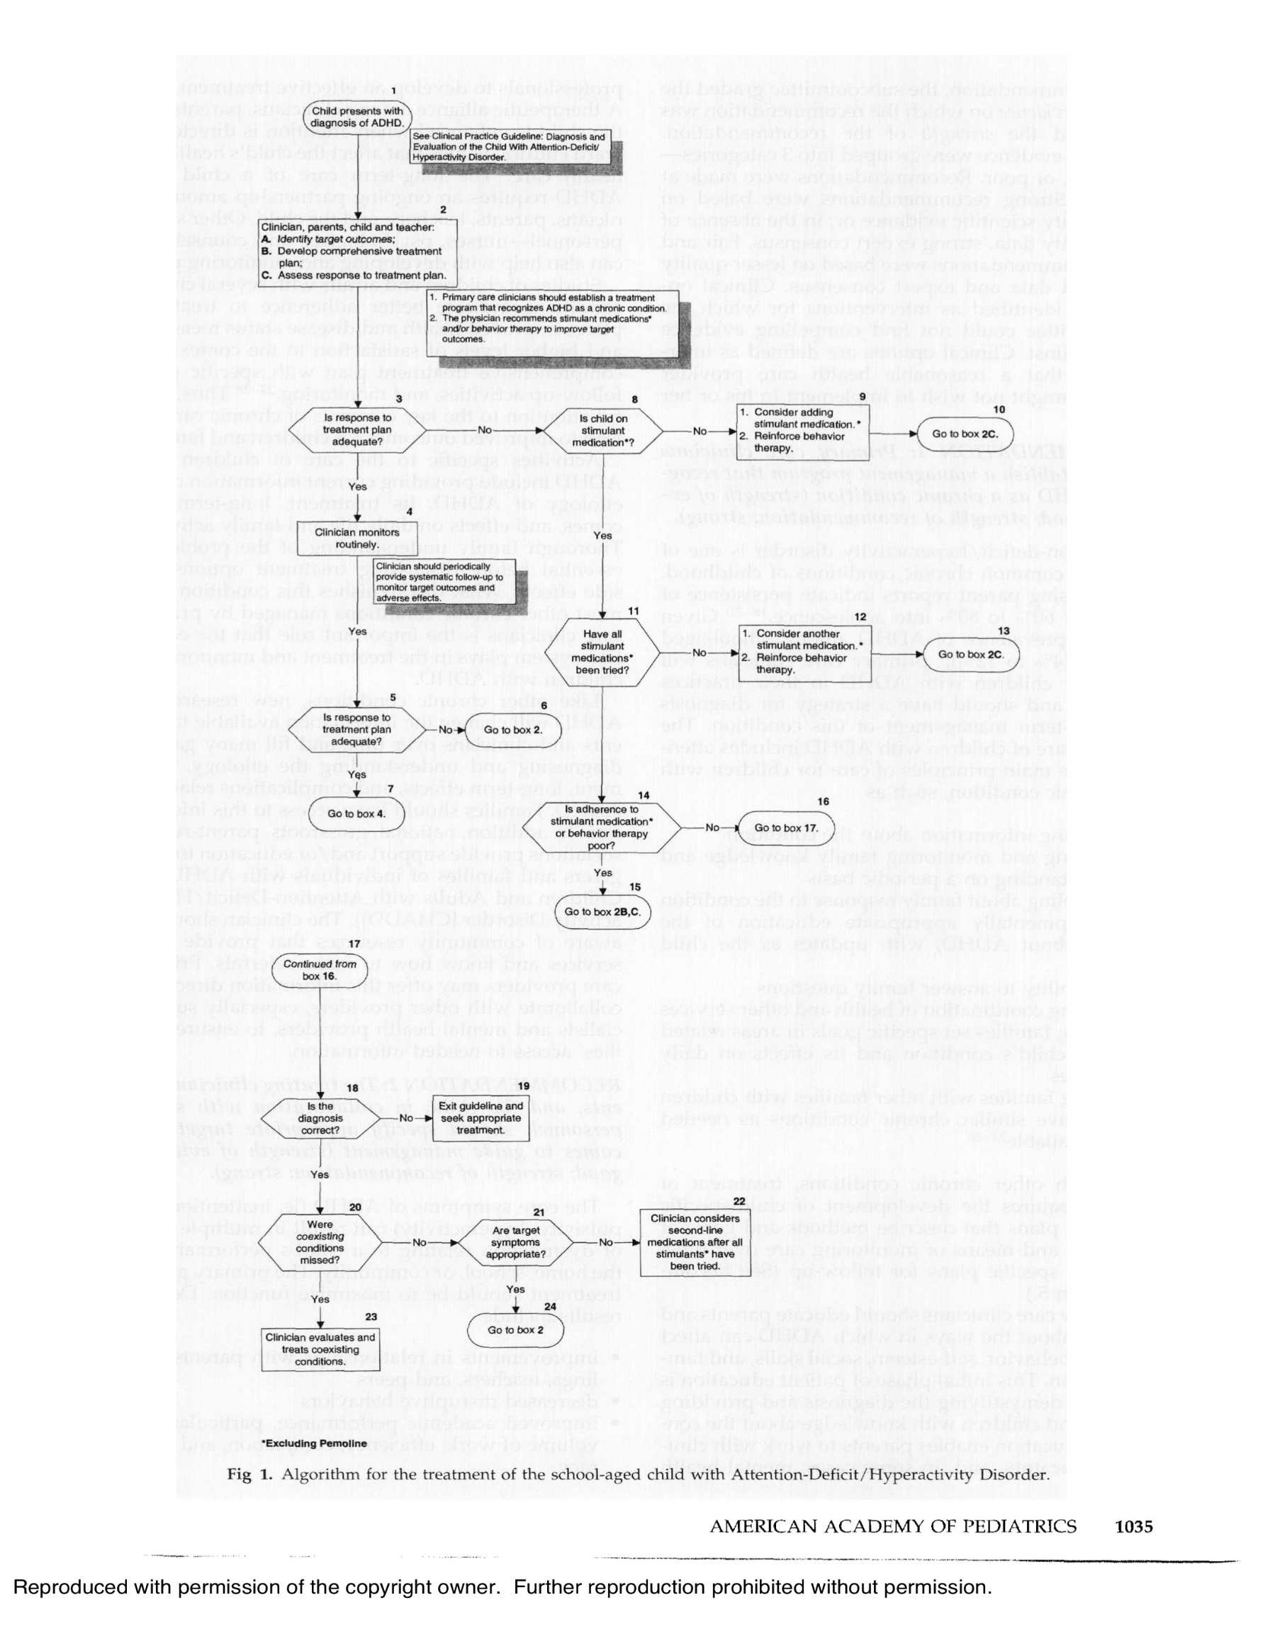

The goal of our project is to create a revolution in the medical field that will offer more accessible and satisfactory treatment in every way to those who need it, by changing the "algorithm" accepted in the world. Our clear vision is to help more children globally, emphasizing their school days in collaboration with the schools and teachers.

## **2.2 Gamification**

Gamification, the application of game design elements in non-game contexts, has rapidly gained traction in various fields, including education, business, and healthcare. This approach uses game mechanics - such as rewards, challenges, and progress tracking - to engage users and motivate behavior change. By incorporating these elements, gamification aims to transform routine tasks and therapeutic activities into more engaging and enjoyable experiences.

In healthcare, gamification has shown promise in improving patient adherence, improving therapeutic outcomes, and promoting healthy behaviors. Interactive games and gamified applications are used to facilitate physical rehabilitation, treat chronic conditions, and promote preventive health measures. These tools engage users by providing real-time feedback, setting achievable goals, and incentivizing progress, which can lead to better health outcomes and increased user motivation.

In the context of ADHD, gamification has been used to address the challenges associated with maintaining attention and controlling impulses. By integrating cognitive challenges and rewarding experiences into gameplay, game-based interventions can support the development of skills crucial to ADHD management. Research shows that such approaches can effectively improve attention, working memory and impulse control and are a valuable complement to traditional treatment methods [7].

The potential of gamification in ADHD treatment is significant. Gamified interventions can increase user engagement and motivation, crucial for adherence to treatment protocols [10]. Games designed to stimulate dopamine production can directly address the neurotransmitter dysregulation seen in ADHD, providing a targeted method for symptom management [11]. Research indicates that digital therapeutics, including cognitive training games and neurofeedback, can produce significant improvements in attention and executive functioning in individuals with ADHD [9].

**Potential Risks of Excessive Mobile Game Use**

While gamification offers significant benefits, it is important to be aware of potential risks associated with overusing mobile games. Increased screen time can lead to issues such as decreased physical activity, disrupted sleep patterns and increased screen addiction. Excessive gaming can also impair cognitive development, particularly in children, by reducing time spent on other critical activities such as academic learning and social interactions [7]. Additionally, long-term overuse of

mobile games have been linked to mental health concerns like anxiety and depression due to social isolation and overdependence on digital platforms [9].

## **2.3 Current Solutions and Limitations**

In recent years, digital interventions have emerged as promising supplementary treatments for ADHD. One notable example is EndeavorRx, an FDA-approved video game designed to treat pediatric ADHD by targeting neural systems involved in attention through sensory stimuli and motor challenges [7]. Other mobile applications like Cogmed and BrainBeat offer cognitive training exercises aimed at improving attention and working memory [8]. Biofeedback and neurofeedback methods use real-time monitoring of physiological signals to teach individuals how to regulate their brain function and improve attention [9].

Research consistently highlights dopamine's critical role in ADHD. Dopamine dysregulation is linked to core symptoms such as inattention, impulsivity, and hyperactivity [12]. Interventions that effectively increase dopamine levels are therefore highly relevant for ADHD treatment. The success of digital health solutions like EndeavorRx demonstrates the potential of this approach, providing scalable, cost-effective, and easily accessible treatment options [7].

However, EndeavorRx has certain limitations, such as: requires certain devices (iOS-based tablets) and internet access that may not be available to all users at all times. EndeavorRx can also be expensive for some families, as it may require a prescription and ongoing subscription fees. Another concern with mobile game is the potential for overuse, as there is a risk of children spending excessive time on screens, leading to issues like decreased physical activity, disrupted sleep, or increased screen addiction. Additionally, some children might experience frustration or stress if they struggle with EndeavorRx's tasks. Finally, EndeavorRx is designed for children aged 8-17, limiting its applicability for younger children or adults with ADHD.

These advantages suggest that while EndeavorRx can be a helpful tool for managing ADHD symptoms, it may not be suitable for everyone. The "Dopamine Booster Game" addresses these limitations, offering an inclusive, cost-effective, and engaging solution for ADHD treatment.

In conclusion, while existing treatments for ADHD, including medication and behavioral therapy, are effective, they have limitations that necessitate the development of innovative interventions. Digital therapeutics and gamification offer promising new avenues for ADHD treatment. The "Dopamine Booster Game" builds on this foundation by targeting dopamine production through interactive gameplay, providing a scientifically grounded and engaging tool to improve attention and concentration in children with ADHD.

# 

# **3 Expected Achievements**

## **3.1 Outcomes**

The "Dopamine Booster Game" project aims to create a comprehensive and innovative solution for managing ADHD symptoms. Our project will focus on developing several key achievements and products that will collectively form an effective and engaging intervention for individuals with ADHD. The following outlines the expected achievements of our project:

**Interactive Mobile Application**

The primary product of our project will be a fully functional mobile application available on multiple platforms (iOS, Android). This application will be designed to support a wide range of devices, ensuring accessibility for all users. The game will incorporate engaging and interactive activities specifically designed to stimulate dopamine production. These activities will be based on neuroscientific research and tailored to address the core symptoms of ADHD, such as inattention, impulsivity, and hyperactivity. The application will feature a user-friendly interface with intuitive navigation, making it accessible for children, teenagers, and adults with ADHD.

**Dopamine-Stimulating Game Mechanics**

The game will utilize specific mechanics to stimulate dopamine production, such as reward systems, progressive challenges, and goal-setting elements. These mechanics will be integrated into the gameplay to ensure a motivating and rewarding experience for users. Activities within the game will include tasks that require sustained attention, problem-solving, and impulse control. As part of the application in between game sessions, students will participate in solving exercises assigned to them by their teacher, designed to improve their problem-solving skills and cognitive reaction times. By incorporating game mechanics aimed at quick decision-making and accuracy, the game aims to reduce thinking time and improve the correctness of answers, ensuring that players not only enjoy the process, but also achieve measurable improvements in their cognitive performance and have a desire to continue improving by using our platform.

**Personalized User Experience**

The application will include a customized user experience, adapting the difficulty and nature of tasks based on individual performance and progress. This personalization helps maintain user engagement and better student-teacher interaction, ensuring activities are appropriately challenging for each user. As students progress through the game and show improvement, the tasks become more challenging. Those who struggle with certain exercises receive adjustments to create a balanced and motivating learning environment and make it easier for teachers and students to achieve their goals and receive a proper assessment.

**Integration of Physical Activity**

To address the potential risks of excessive screen time, the game monitors and limits play time overall and for each gaming session while incorporating elements of physical activity. Certain tasks will require physical movement, promoting a healthy balance between screen-based activities and physical exercise. These physical tasks will be designed to be fun and engaging, ensuring that users enjoy the activities while also benefiting from increased physical activity.

## **3.2 Success Criteria**

The success of the "Dopamine Booster Game" project will be measured based on several key criteria

**Improvement in ADHD Symptoms**

Success is determined by measurable improvements in ADHD symptoms, particularly inattention, impulsivity and hyperactivity. These improvements will be assessed through a combination of pre- and post-intervention assessments using standardized ADHD rating scales, such as the *ADHD Rating Scale-IV* [13]. Additionally, exercises related to the game's cognitive training activities are incorporated at the end of each session. The results of these exercises provide quantifiable data about the user's progress over time and provide immediate feedback on attention and focus improvements.

In addition, at the beginning of the school year, teachers complete a detailed observation questionnaire (see Appendix A) that serves as a baseline for each student. Teachers then complete the same questionnaire at key intervals throughout the school year to track behavioral changes and academic performance. This combination of game-based assessments (per session and total usage) and teacher-reported data provides a robust framework for evaluating the effectiveness of the "Dopamine Booster Game" in improving ADHD symptoms.

**User Satisfaction**

User satisfaction will be gauged through surveys and feedback forms, focusing on the game's usability, enjoyment, and perceived benefits. Positive feedback and high satisfaction ratings will be key indicators of success.

**Accessibility and Inclusivity**

The application’s ability to support multiple devices and platforms, along with its inclusivity for different age groups and demographics, will be crucial for its success. Widespread accessibility will demonstrate the game’s potential to reach a broad audience.

**Scalability and Testing**

The application's scalability, including its potential for widespread adoption in various settings (e.g., schools, clinics, and homes), will be a significant measure of success. To further ensure scalability and adoption, we plan to design school experiments to evaluate the game's effectiveness in real-world educational settings. These experiments will involve teachers and students in a controlled setting where the game will be introduced as part of the classroom routine. After a few minutes of gameplay, teachers will observe and provide feedback on whether the game helps improve students' attention and concentration during class activities. This feedback will be crucial in refining the development of the game's design and functionality to better serve its intended purpose, until the stage where it is ready to move to a clinical trial.

**Recognition and Adoption in the medical field**

Gaining recognition and publication in the medical field is essential for the success of the "Dopamine Booster Game". This will involve rigorous clinical trials, peer-reviewed publications, and endorsements from leading medical professionals and institutions. Integrating the game into existing treatment plans will ensure its acceptance as an effective ADHD intervention. By incorporating this digital tool into the traditional treatment, we aim to revolutionize ADHD management, providing a more updated and accessible solution. The following figure illustrates the integration of our game into the current ADHD traditional treatment algorithm to suggest a new and improved algorithm.

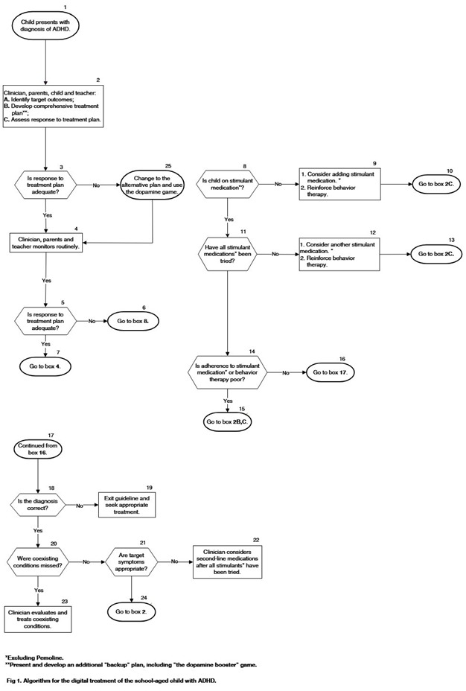Figure 2: Suggested Algorithm for treatment of the school-aged child with ADHD.

By achieving these goals, the "Dopamine Booster Game" project will provide a scientifically grounded, engaging, and accessible tool for managing ADHD symptoms, offering a valuable alternative or supplement to traditional treatments and thus fulfilling our vision and expanding it to another target audience.

# **4 Research and Engineering Process**

The information gathering and learning process until now was mostly split between the largest parts of the project: theoretical knowledge, concerned with understanding what is ADHD and the practical considerations of how to approach to global mobile development from a software and hardware perspective.

## **4.1 Process**

### **4.1.1 Research - Enhancing ADHD Treatment**

In this initial phase of the project, our team focused on developing the theoretical framework for our software solution. This involved conducting a thorough literature review to identify existing methods and tools for ADHD management and digital interventions. Through this review, we established the foundational knowledge necessary for the design of our innovative mobile application, the "Dopamine Booster Game."

Based on our research findings, we developed a conceptual model for our software solution, outlining the main features, algorithms, and methodologies that will be implemented to stimulate dopamine production and improve attention and concentration in users. Additionally, we formulated a detailed project plan, delineating key milestones and deliverables essential for the development process.

To plan our development, we identified the technical requirements for our software solution, including hardware and software specifications, data storage and user interface design. This information guided our selection of appropriate tools and technologies, prioritizing factors such as compatibility, scalability, and ease of use.

Throughout this theoretical development process, we regularly reviewed and evaluated our progress, using insights from our project advisor and literature review to refine our conceptual model and project plan. By the end of this phase, we aimed to have a well-defined and comprehensive theoretical framework for our software solution, establishing a solid foundation for the subsequent phases of the project.

**Initial Research/Experiments**

We explored various game mechanics and interactive designs that could effectively engage users while promoting cognitive training. Although no prototypes were developed at this stage, our research laid the groundwork for future design and implementation efforts.

These initial explorations revealed promising avenues for creating engaging gameplay experiences that could potentially lead to significant improvements in ADHD symptom management.

**Research Challenges**

Several challenges need to be addressed to achieve the expected outcomes:

**User Engagement:** Creating a game that maintains user interest and encourages regular engagement poses a significant challenge. It is crucial to balance fun and educational elements to ensure sustained interaction.

**Algorithm Selection:** Identifying the most suitable algorithms for personalized user experiences is essential. The chosen algorithms must adapt to individual performance and preferences while providing effective dopamine stimulation.

**Complex User Interface Design:** Developing an intuitive and accessible user interface that provides to a broad age range and varying levels of technological proficiency requires careful consideration and design iterations.

By addressing challenges related to user engagement, algorithm selection, and user interface design, the proposed solution intends to provide individuals with ADHD a powerful tool for managing their symptoms effectively.

### **4.1.2 Research – Cross Platform Mobile Development**

In this section, the focus is on researching and identifying the optimal approach for developing a cross-platform mobile application for the "Dopamine Booster Game". Cross-platform development is essential for ensuring the app is accessible to a broad user base across different devices and operating systems, including iOS and Android.

**Definition of Cross-Platform Mobile Development**

Cross-platform mobile development refers to the process of creating software applications that are compatible with multiple mobile operating systems from a single codebase. Unlike native development, where separate codebases are maintained for each platform (iOS and Android), cross-platform development uses frameworks and tools that enable developers to write shared part of code once and deploy it across various platforms. Platform refers to the type of processor (CPU) or other device hardware on which an operating system (OS) or application runs, the type of OS, or a combination of the two. This approach not only reduces development time and costs but also simplifies maintenance and updates. Popular cross-platform frameworks include Flutter, React Native, and Xamarin, each offering unique features and advantages tailored to different project needs.

When developing a 3D mobile game, several cross-platform solutions are available. Popular frameworks include Unity, which is widely used for 3D game development due to its robust engine and extensive support for physics, rendering, and animations across platforms like iOS and Android. Unreal Engine is another powerful option, known for delivering high-quality graphics but often more resource intensive. React

Native and Flutter offer cross-platform capabilities for general app development but lack native 3D rendering support. To leverage the strengths of both worlds, our solution integrates Unity for handling 3D game mechanics, while Flutter is used to build the user interface and manage non-3D features. This hybrid approach allows us to benefit from Unity's advanced 3D capabilities while taking advantage of Flutter's fast, responsive UI and native-like performance across multiple devices. By combining these technologies, we ensure a seamless and optimized experience for users, regardless of platform.

## **4.2 Product**

### **4.2.1 Requirements**

**Functional:**

|  |  |
| --- | --- |
| 1 | The system allows users to sign up, log in, and log out. |
| 2 | The system supports third-party authentication login (e.g., Google, Facebook). |
| 3 | The system allows users to track their progress and performance over time. |
| 4 | The system includes reward activities, progressive challenges, and goal-setting elements. |
| 5 | The system adapts the difficulty of tasks based on individual performance set by the teacher. |
| 6 | The system includes tasks that require sustained attention, problem-solving, and impulse control. |
| 7 | The system includes elements that encourage physical activity, such as tasks requiring physical movement. |
| 8 | The system provides daily feedback on user performance. |
| 9 | The system includes a reward system to motivate and engage users. |
| 10 | The system collect data on user performance and engagement. |
| 10.1 | The system analysis this data to provide personalized recommendations. |
| 11 | The system provides a separate interface for teachers or parents to monitor the progress of the children using the app. |
| 12 | The system allows teachers or parents to provide feedback on the game's impact on the users. |
| 13 | The system allows to add questions and answers by the teacher interface. |
| 14 | The system allows student to answer and submit answers for teacher assignment |
| 15 | The system allows automatic feedback of the grade of student assignments for the teacher. |

**Non-Functional:**

1. **Performance**
   * The application shall have a response time of less than 2 seconds for user interactions.
   * The application shall handle up to 1000 concurrent users without performance degradation.
2. **Scalability**
   * The application shall be able to scale horizontally to accommodate an increasing number of users.
3. **Security**
   * The application shall ensure user data is encrypted in transit.
4. **Usability**
   * The application shall have an intuitive and user-friendly interface.
   * The application shall be accessible to users of all ages, with special consideration for children with ADHD.
5. **Compatibility**
   * The application shall be compatible with both iOS and Android devices.
   * The application shall support a wide range of device screen sizes and resolutions.
   * The application shall support both English and Hebrew languages, allowing users to switch between them seamlessly.
6. **Reliability**
   * The application shall be resilient to data loss with regular backups.
7. **Maintainability**
   * The application shall be designed with a modular architecture to allow for easy updates and feature additions.

### **4.2.2 Diagrams and Interfaces**

*Use-case Diagram*

The following Use Case diagram shows the Student, Parent and Teacher Interaction with the system.

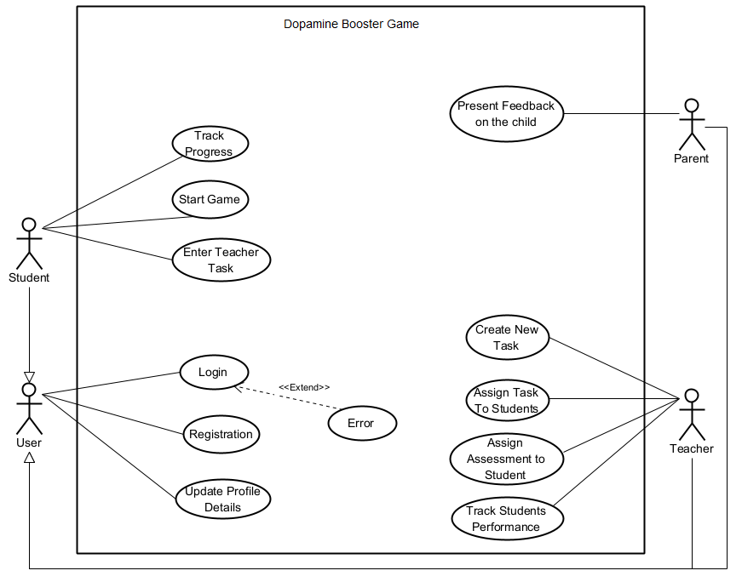

Figure 3: Use-Case Diagram of "Dopamine Booster Game".

*Activity Diagram*

This activity diagram outlines the interaction process between students and teachers within the game, highlighting the balance between educational tasks and gameplay rewards.

Figure 4: Activity Diagram of "Dopamine Booster Game".

*Login Interface*

Figure 5: Prototype Login interface of "Dopamine Booster Game".

Figure 5: The image shows the representative prototype of the Dopamine Booster Game and the login screen. This provides users with a visual preview of the game's interface and how students will access the platform before starting the gameplay experience.

Figure 6: Prototype Student Task interface of "Dopamine Booster Game".

Figure 6: The image represents a task screen that students will access after playing the 3D game to work on his assigned task by his teacher. This assessment follows gameplay in the Dopamine Booster Game, which is designed to test their cognitive abilities, such as concentration, after boosting dopamine levels through the gam

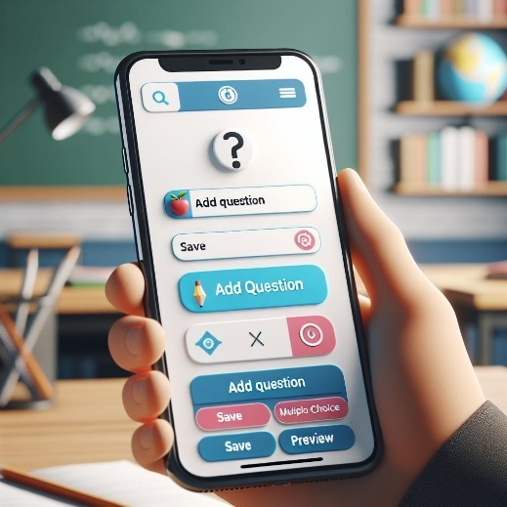

Figure 7: Prototype Teacher interface of "Dopamine Booster Game".

Figure 7: The image shows part of the teacher's interface, where they can add questions for students based on lesson material. This feature allows teachers to create custom tasks that align with their classroom content specific to the required student.

# **5 Software Design and Architecture**

The software design and architecture for the “Dopamine Booster Game” project are crucial for creating a robust, scalable, and user-friendly application. This section outlines the primary components of the system architecture, design patterns, and how they work together to ensure optimal performance and ease of maintenance.

The architecture of the “Dopamine Booster Game” is designed to maximize efficiency and provide a seamless user experience. The system follows a modular approach, breaking down the application into distinct components that interact with each other. This modularity allows for easier updates, testing, and maintenance.

**Front-End (Client-Side)**

Platform: The mobile application will be developed using a combination of Flutter and Unity. Flutter will handle the user interface and user experience elements, ensuring a smooth and responsive design across different devices. Unity will be used for developing the 3D game mechanics and interactive elements, leveraging its powerful game engine capabilities to create engaging and immersive gameplay to stimulate dopamine production.

User Interface: Flutter's rich widget library will be employed to create an intuitive and user-friendly interface, while Unity will manage the 3D rendering and interactive components of the game. This combination allows for high performance and a visually appealing experience.

**Back-End (Server-Side)**

Database: Firebase will serve as the primary database solution for the application. Firebase offers a real-time database, which means that the data can be synchronized instantly across all devices. This is crucial for a game that relies on real-time updates and user interactions. The database will store user profiles, game progress, and other relevant data.

Data Management: With Firebase, data will be managed directly without the need for a traditional API. Firebase's built-in capabilities for authentication, real-time data synchronization, and cloud storage will handle all aspects of data management and communication between the client and the server.

**Integration and Communication**

Direct Firebase Integration: The application will interact directly with Firebase for all data operations. This approach simplifies the architecture by eliminating the need for a separate API layer. It also reduces latency and potential points of failure, as all data transactions are handled directly by Firebase's robust infrastructure.

Security: Firebase provides built-in security features such as authentication and authorization rules, ensuring that user data is protected and only accessible by authorized individuals.

**Design Patterns**

MVC (Model-View-Controller): The MVC pattern will be employed to separate the application's concerns, making the codebase more organized and manageable. The Model will handle data interactions and business logic, the View will manage the user interface, and the Controller will facilitate communication between the Model and View.

Observer Pattern: For real-time updates and notifications, the Observer pattern will be used. This pattern allows the application to react to changes in the database immediately, providing a dynamic and responsive user experience.

**Scalability and Performance**

Scalability: By using Firebase and a modular design, the application is built to scale easily. Firebase's cloud infrastructure can handle a large number of concurrent users and data transactions, ensuring that the application performs well under varying loads.

Performance: The choice of Flutter and Unity for front-end development ensures high performance and responsiveness. Unity's game engine will handle complex 3D graphics and interactions, while Flutter's framework will provide a smooth and fluid user interface.

This design and architecture will enable the Dopamine Booster Game to deliver a high-quality, engaging experience while maintaining flexibility and scalability for future updates and enhancements.

# **6 Verification and Evaluation**

## **6.1 Evaluation**

### **6.1.1 Overview**

The test plan outlines the procedures and methodologies to evaluate the effectiveness and performance of the "Dopamine Booster Game" in a real-world classroom setting. The primary goal is to determine whether the game improves attention, concentration, and overall academic performance in children with ADHD.

**Objectives**

* Assess the usability and engagement levels of the game.
* Measure improvements in attention and concentration among students.
* Gather feedback from teachers on the game's impact on student behavior and performance.
* Identify any technical issues or bugs in the game.

**Scope**

* The test will be conducted in a real classroom setting with students diagnosed with ADHD.
* The evaluation period will span one week, incorporating regular 10-15 minute gameplay sessions into the school day.
* Feedback will be collected from both teachers and students.

**Constraints and Assumptions**

* **Constraints:**
  + Limited access to classrooms and students for testing purposes.
  + Variations in how different teachers implement the game sessions and engage students.
  + Limited testing time within the school schedule.
* **Assumptions:**
  + Students and teachers will have access to the necessary hardware (e.g., tablets, smartphones).
  + Teachers will integrate the game sessions seamlessly into the daily class routine.
  + Students will follow instructions and engage with the game as intended.

**Test Environment**

* **Hardware:**
  + Tablets or smartphones for each student to play the game.
* **Software:**
  + The latest version of the "Dopamine Booster Game" application.
  + Data analytics tools to monitor and evaluate student performance.
* **Personnel:**
  + A teacher to oversee the class and manage the testing process.
  + A researcher to collect data, provide technical support, and facilitate the evaluation process.

### 

### **6.1.2 Work Plan**

**Phase 1: Preparation**

1. **Permissions and Approvals:**
   * Obtain necessary permissions from school administration and parents for the participation of students.
   * Ensure ethical guidelines and privacy concerns are addressed.
2. **Setup:**
   * Install the "Dopamine Booster Game" application on all required devices.
   * Ensure all devices are functioning properly and connected to the necessary networks.
3. **Training:**
   * Train teachers on how to use the game and monitor student progress.
   * Provide guidelines on how to integrate the game sessions into the daily class schedule.

**Phase 2: Baseline Measurement**

1. **Initial Assessments:**
   * Conduct initial assessments to measure students' current levels of attention, concentration, and academic performance.
   * Utilize standardized tests or teacher observations to establish a baseline for comparison.
2. **Data Collection:**
   * Record baseline data to serve as a reference point for evaluating improvements.

**Phase 3: Implementation**

1. **Gameplay Sessions:**
   * Incorporate 10-15 minute game sessions into the daily school schedule for one week.
   * Ensure that each student plays the game for the designated time each day.
2. **Monitoring:**
   * Monitor student engagement and participation during game sessions.
   * Ensure technical issues are promptly addressed to minimize disruptions.

**Phase 4: Mid-Test Evaluation**

1. **Preliminary Feedback:**
   * Conduct a mid-test evaluation to gather preliminary feedback from teachers and students.
   * Observe student engagement and any immediate behavioral changes.
2. **Adjustments:**
   * Make any necessary adjustments to the testing process based on preliminary feedback.

**Phase 5: Final Assessment**

1. **Post-Test Assessments:**
   * At the end of the one-week period, conduct final assessments to measure any improvements in attention, concentration, and academic performance.
   * Utilize the same standardized tests or observational methods as the baseline measurement for consistency.
2. **Data Collection:**
   * Record post-test data to compare with baseline measurements.

**Phase 6: Feedback Collection**

1. **Teacher Feedback:**
   * Conduct interviews or surveys with teachers to gather detailed feedback on the game's impact on student behavior and performance.
   * Ask teachers to provide specific examples and observations.
2. **Student Feedback:**
   * Collect feedback from students about their experience with the game.
   * Use age-appropriate methods such as surveys or informal discussions to gather their insights.

### **6.1.3 Final Evaluation Stage**

* **Quantitative Data:**
  + Pre and post-test scores on attention and concentration assessments.
  + Game usage statistics (e.g., time spent playing, levels completed).
* **Qualitative Data:**
  + Teacher feedback on student behavior and performance.
  + Student feedback on game enjoyment and engagement.

**Analysis Methods:**

* **Comparative Analysis:**
  + Compare pre and post-test scores to determine improvements in attention and concentration.
  + Analyze changes in academic performance metrics.
  + An opinion from the teacher as to whether an improvement was made.
* **Usage Analysis:**
  + Evaluate game usage statistics to identify patterns in engagement and usage frequency.

### **6.1.4 Reporting**

1. **Report Compilation:**
   * Compile a comprehensive report detailing the test findings.
   * Include both quantitative and qualitative data analyses.
2. **Key Sections:**
   * **Introduction:**
     + Overview of the test plan and objectives.
   * **Methodology:**
     + Detailed description of the testing procedures and environment.
   * **Results:**
     + Presentation of quantitative improvements in attention, concentration, and academic performance.
     + Summary of qualitative feedback from teachers and students.
   * **Discussion:**
     + Analysis of the findings and their implications.
     + Identification of any technical issues or areas for improvement.
   * **Conclusion:**
     + Summary of key insights and recommendations for future development.

By following this comprehensive test plan, we aim to rigorously evaluate the "Dopamine Booster Game" in a real-world educational setting. This will ensure that the game is both effective and user-friendly, ultimately providing a valuable tool for children with ADHD to manage their symptoms through engaging and interactive gameplay.

## **6.2 Verification**

The testing for the 'Dopamine Booster Game' will be conducted iteratively across the following areas: Mobile Application – Data Analysis – Game Mechanics. We will employ unit tests, functional tests, and manual QA for user experience testing.

The Unity Test Framework will be used for the Mobile Application and Game Mechanics, while the data processing will be tested with accuracy matrices and mock data. The goal is to ensure proper functionality, user satisfaction, and reliable data output.

|  |  |  |  |
| --- | --- | --- | --- |
| **Test** | **Module** | **Tested Function** | **Expected Result** |
| 1 | Mobile Application | Game Loading | Fast game load time < 2s |
| 2 | Mobile Application | Steady framerate | Minimum of 30 fps maintained |
| 3 | Mobile Application | UI/UX | Intuitive and user-friendly interface |
| 4 | Mobile Application | Device Compatibility | Supports all mobile devices (Android, iOS) |
| 5 | Mobile Application | Transition Between Screens | Smooth transitions < 2s |
| 6 | Mobile Application | Feedback Adaptability | The game stage adjusts based on the teacher assessment grade. |
| 7 | Mobile Application | Reward System | Rewards triggered by achieving points milestones |
| 8 | Game Mechanics | Response to Inputs | Accurate and quick response to user inputs |
| 9 | Game Mechanics | Authentication System | User can log in with valid credentials (student, parent, teacher) |
| 10 | Game Mechanics | Physical Activity Integration | Device notification displayed |
| 11 | Game Mechanics | Limiting Screen Time | Game enforces screen time limits, based on settings |
| 12 | Data Analysis | Accurate Logging of User Performance | Performance data (tasks completed, response times) correctly logged |
| 13 | Data Analysis | Data Sync with Database | Data syncs correctly with database storage for analysis |

# **7 References**

1. HK Paediatric Society (2005). Clinical practice guideline: Treatment of the school-aged child with attention-deficit/hyperactivity disorder. Pediatrics, 108(4), 1033-1044.
2. Orr, J. M., Miller, R. B., & Polson, D. M. (2007). Toward a standard of care for child ADHD: Implications for marriage and family therapists. Journal of Marital and Family Therapy, 31(3), 191-205.
3. Biederman, J., & Faraone, S. V. (2005). Attention-deficit hyperactivity disorder. The Lancet, 366(9481), 237-248.
4. Stevens, J. R., et al. (2013). Side effects of stimulant medication for ADHD. Journal of the American Academy of Child & Adolescent Psychiatry, 52(3), 249-259.
5. Knouse, L. E., & Safren, S. A. (2010). Current status of cognitive behavioral therapy for adult attention-deficit hyperactivity disorder. Psychiatric Clinics of North America, 33(3), 497-509.
6. Sonuga-Barke, E. J. S., et al. (2013). Nonpharmacological interventions for ADHD: Systematic review and meta-analyses of randomized controlled trials of dietary and psychological treatments. American Journal of Psychiatry, 170(3), 275-289.
7. Kollins, S. H., et al. (2020). A novel digital intervention for actively reducing ADHD symptoms in children: Results from a randomized controlled trial. The Lancet Digital Health, 2(4), e168-e178.
8. Chacko, A., et al. (2013). Cognitive training for children with ADHD: A randomized controlled trial of Cogmed Working Memory Training and ‘paying attention in class’. Journal of Child Psychology and Psychiatry, 54(3), 309-319.
9. Cortese, S., et al. (2016). Neurofeedback for ADHD: A review of recent randomized controlled trials. Journal of Attention Disorders, 20(9), 803-811.
10. Deterding, S., et al. (2011). From game design elements to gamefulness: Defining “gamification”. Proceedings of the 15th International Academic MindTrek Conference: Envisioning Future Media Environments.
11. Koepp, M. J., et al. (1998). Evidence for striatal dopamine release during a video game. Nature, 393(6682), 266-268.
12. Volkow, N. D., et al. (2009). The dopamine system in ADHD. The American Journal of Psychiatry, 166(8), 1024-1025.
13. G. J. DuPaul, T. J. Power, A. D. Anastopoulos, and R. Reid (1998), ADHD Rating Scale-IV (ADHD-RS-IV: Home Version), APA PsycTests.

**Link to Project GitHub Repository:** [Dopamine-Booster-Game](https://github.com/YuvalHilay/Dopamine-Booster-Game)

# **8 AI-Tools**

Prompt 1

User's Query: I need to create screens as a prototype for a screen application called “Dopamine Booster”, which is actually a game for children to improve attention and concentration, I need to make login screens, the game itself, a screen with a menu for the teacher who can set a playing time for the student, a menu for the teacher who can ask questions and a menu for the student who can answer the questions. In addition, I need the screens to look like it's on a smartphone. At first you will only issue a login page so that you don't get into trouble Do not make spelling mistakes and make a more attractive and playful design that is eye-catching for children’s.

Prompt 2

User's Query: During my academic capstone in engineering project, I would like to run an evaluation experiment testing my “Dopamine Game” App in real life classroom, help me understand the preparation to start and run such a complicated process.

Prompt 3

User's Query: I would like to learn more about cross-platform mobile development technology. Conduct deep research and provide me detailed insights about the definitions, frameworks, and their advantages and disadvantages as if you senior mobile game development.

# 

# **9 Appendix**

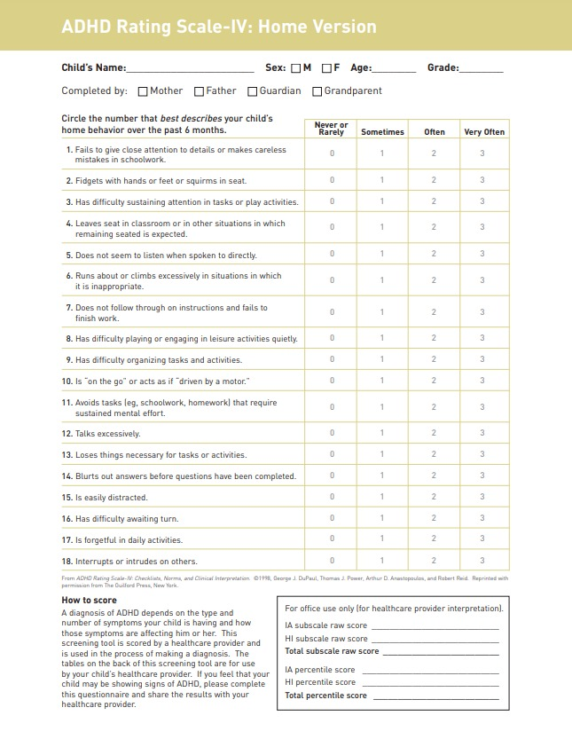Appendix A: ADHD Rating Scale IV

